Steps to configure web server
Single Platform:
- Mount CD1 and install httpd package.
- Go to add or remove packages with following commad:
#redhat-config-packages
Select web server option and go to its details. Now select first two packages i.e. https-manual and hwcrypto
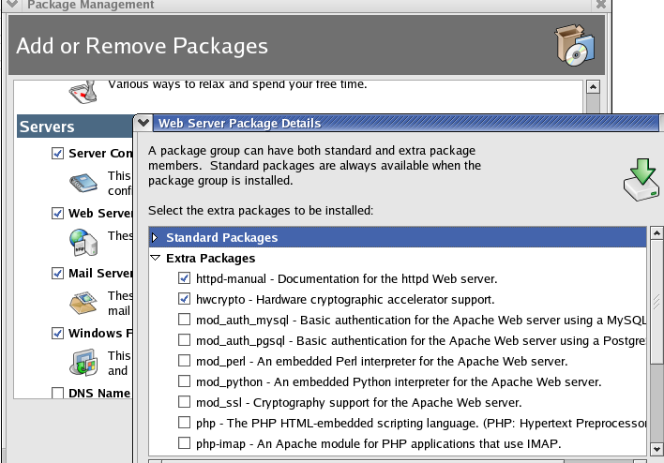
Click on close and update.
- Create a webpage using following commands:
#mkdir /var/www/html/myweb
# gedit /var/www/html/myweb/index.html
- Write html code in this page as follows. Save and close it .
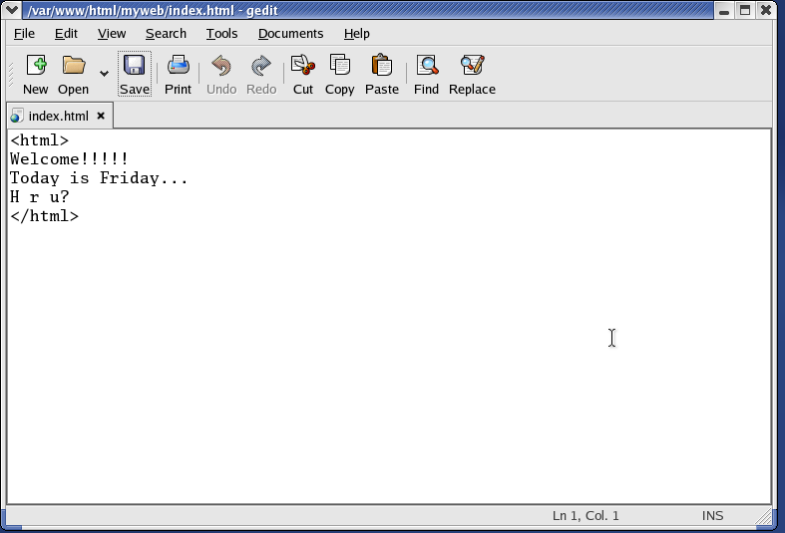
- Now give the permissions to this file:
# chmod 777 /var/www/html/myweb/index.html
- Start the services of httpd:
service httpd start/restart
- Open browser and type:
http://localhost

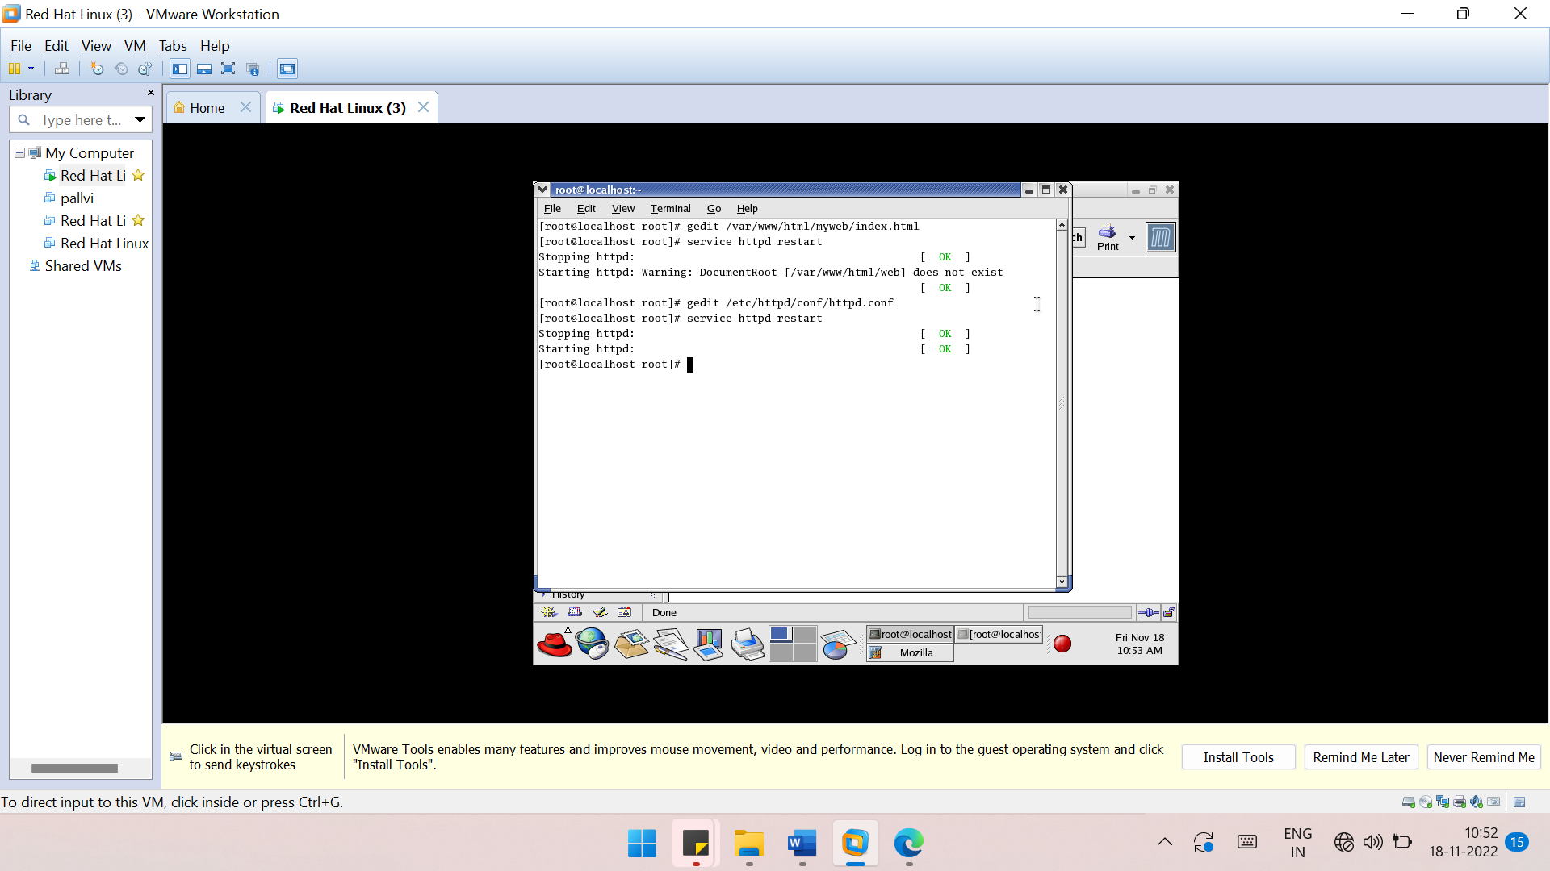
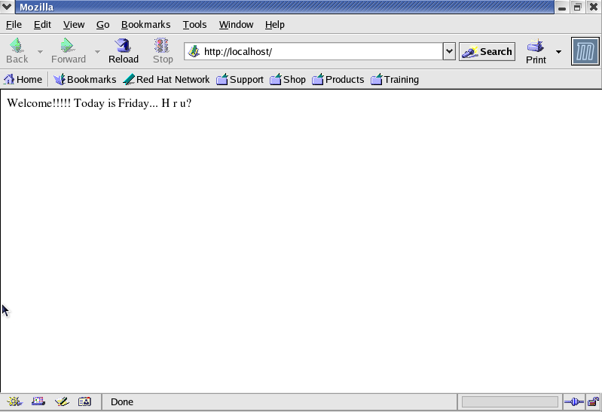

Cross Platform
- Follow steps 1 to 6 of single platform.
- Restart internet service and stop iptables:
#service network restart
#service iptables stop
- Now make the following changes to httpd.conf:
#gedit /etc/httpd/conf/httpd.conf
Remove # from infront of following three lines:
ServerRoot “/etc/httpd”
Listen 80
DocumentRoot “/var/www/html”
Now go to the end of the file, copy <virtualhost>…..</virtualhost> ,paste it just below and make the changes to the copied code as per the following screenshot:
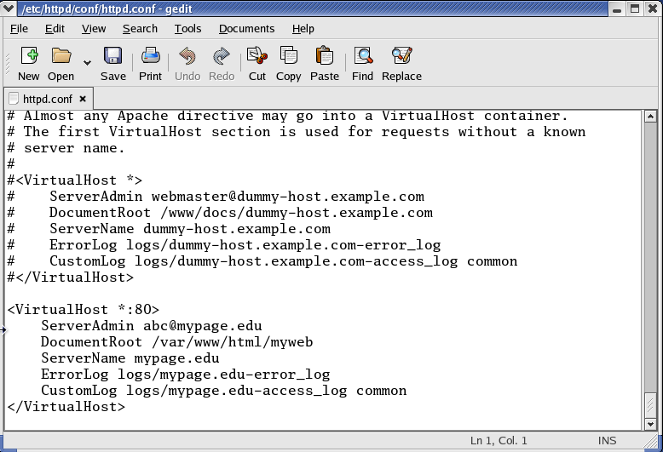
Save the file and close it.
- #service httpd restart
#ip addr show //to check ip address
- Now edit the hosts file and type ip address and server name to this file as follows:
#gedit /etc/hosts
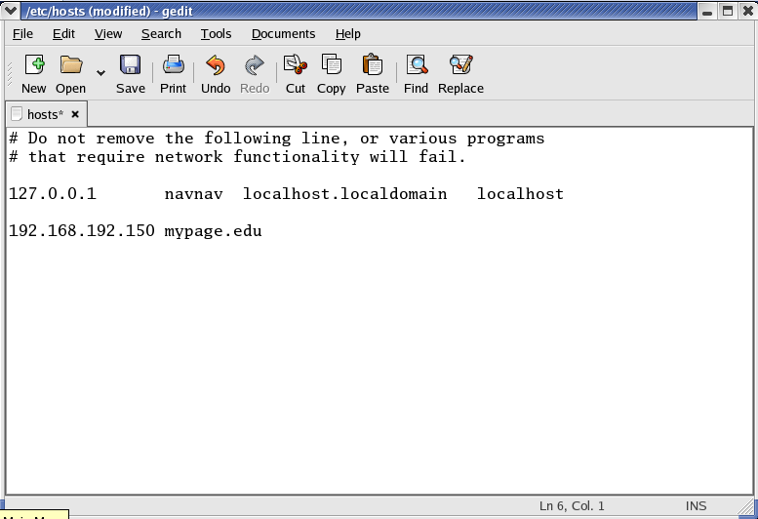
Don’t delete the already written text. Just add ip address and server name below the already written code.
Save and close the file.
- Go to windows →Control Panel→System and Security→Windows Firewall→Turn windows firewall off.
- Control Panel→Programs and Features→ Turn windows features on/off→Select Internet Information services.
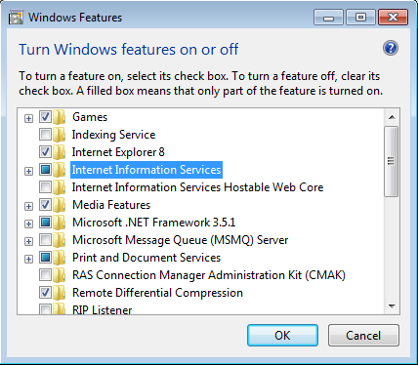
- Now go to C:\Windows\System32\drivers\etc. Copy hosts file from here and paste it to desktop.
- Open hosts file from desktop and type ip address and server name to this file (same like point no. 5) as follows:
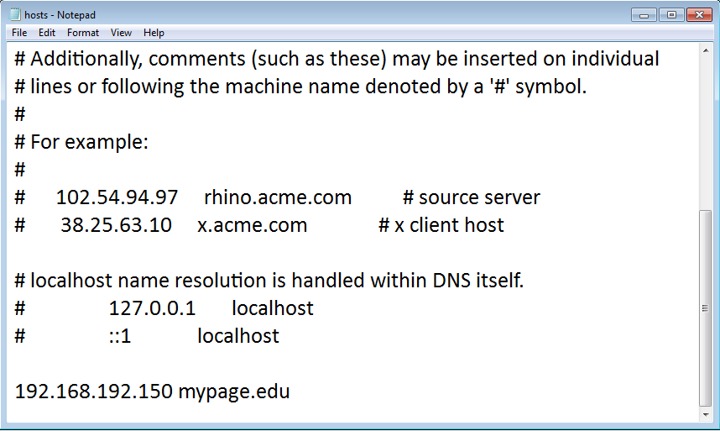
- Cut the file from desktop and paste it to C:\Windows\System32\drivers\etc.
- Go to browser and type mypage.edu.
